Singing effect - The piezoelectric effect occurs in ferroelectric capacitors (i.e. class II & III). Class I capacitors are not ferroelectric and therefore do not exhibit a piezoelectric effect. It is also important to understand that not all ferroelectric capacitors will experience a piezoelectric effect. A specific combination of component construction and circuit usage conditions must exist in order to cause the capacitor to vibrate or ring.

Class 1 capacitor code

To define the performance of a ceramic capacitor dielectric a three-character code is used which is specific to ceramic capacitor class 1 dielectrics.

* The first character is a letter which gives the significant figure of the change in capacitance over temperature in ppm/°C
* The second character is numeric and gives the multiplier
* The third character is a letter and gives the maximum error in ppm/C

|  |  |  |  |  |  |
| --- | --- | --- | --- | --- | --- |
| **FIRST CHARACTER** |  | **SECOND CHARACTER** |  | **THIRD CHARACTER** |  |
| **LETTER** | **SIG FIGS\*** | **DIGIT** | **MULTIPLIER 10X** | **LETTER** | **TOLERANCE** |
| C | 0.0 | 0 | -1 | G | +/-30 |
| B | 0.3 | 1 | -10 | H | +/-60 |
| L | 0.8 | 2 | -100 | J | +/-120 |
| A | 0.9 | 3 | -1000 | K | +/-250 |
| M | 1.0 | 4 | +1 | L | +/-500 |
| P | 1.5 | 6 | +10 | M | +/-1000 |
| R | 2.2 | 7 | +100 | N | +/-2500 |
| S | 3.3 | 8 | +1000 |  |  |
| T | 4.7 |  |  |  |  |
| V | 5.6 |  |  |  |  |
| U | 7.5 |  |  |  |  |

Class 2, 3 Capacitor codes

The three-character code with the letter-number-letter format is used for [capacitors](https://eepower.com/textbook/vol-i-foundations-power-design/chapter-2-analysis-ac-systems/capacitors-and-inductors) with Class 2 and Class 3 dielectrics. X5R and X7R are in Class 2, and Y5V is in Class 3.

* The first character indicates the lowest temperature that the capacitor can handle. The letter X (as in X7R, X5R) corresponds to –55°C.
* The second character indicates the maximum temperature. The theoretical range is from 45°C to 200°C; 5 (as in X5R) corresponds to 85°C, and 7 (as in X7R) corresponds to 125°C.
* The third character indicates the maximum amount of capacitance change over the part’s temperature range. The spec for --R capacitors (such as X5R and X7R) is ±15%. The capacitance of parts with a code ending in V can actually decrease by as much as 82%! This probably explains why Y5V capacitors are not so popular.

|  |  |  |  |  |  |
| --- | --- | --- | --- | --- | --- |
| **FIRST CHARACTER** |  | **SECOND CHARACTER** |  | **THIRD CHARACTER** |  |
| **LETTER** | **LOW TEMP** | **DIGIT** | **HIGH TEMP** | **LETTER** | **CHANGE** |
| X | -55C (-67F) | 2 | +45C (+113F) | D | +/-3.3% |
| Y | -30C (-22F) | 4 | +65 (+149F) | E | +/-4.7% |
| Z | +10C (+50F) | 5 | +85 (+185F) | F | +/-7.5% |
|  |  | 6 | +105 (+221F) | P | +/-10% |
|  |  | 7 | +125 (+257F) | R | +/-15% |
|  |  |  |  | S | +/-22% |
|  |  |  |  | T | +22% / -33% |
|  |  |  |  | U | +22% / -56% |
|  |  |  |  | V | +22% / -82% |

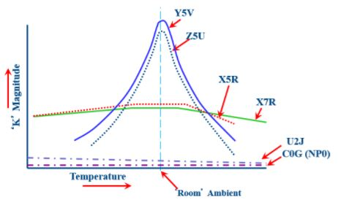

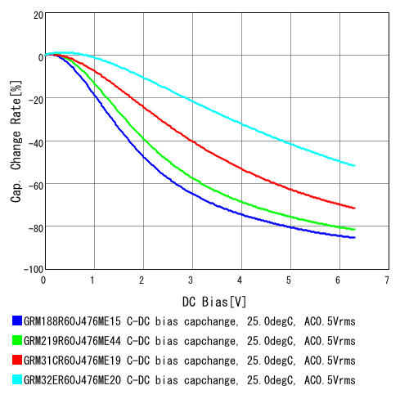

ME15 – 0603   
ME44 – 0805  
ME19 – 1206  
ME20 – 1210  
Cap value – 47uF, Tolerance – 20%

Larger package, lesser variance in capacitance with DC bias, same type

Lower capacitance, same package, nearly identical with diff in type

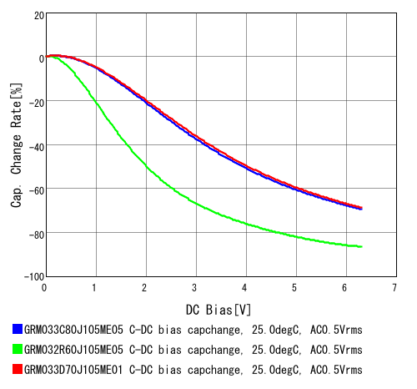

32R – X5R  
33C – X6S  
33D – X7T

Conclusion 1 -

* For capacitor on HPL and HPR, decided to use 1206 capacitor as it has lesser variation over DC bias.
* We shall be testing 47uF and 100uF both. In theory there will be higher distortion for 47uF in lower freq, impedance of the HP is 16ohms. Lower the cutoff, the better
* To prevent harmonics, and microphonics we shall be using C0G.

Need to size caps on SPVDD, HPVDD and MIC1LP

Need to decide whether 0.47 or 1uF on MIC1LP

|  |  |  |  |
| --- | --- | --- | --- |
| Location | Sizing | Type | Value |
| MIC1LP | 0603 | MLCC/Tantalum | 0.47uF |
| SPVDD | 1206  0402 | MLCC | 47uF  0.1uF |
| HPVDD | 0603  0402 | MLCC | 10uF  0.1uF |
| HPL/R | 1206 | Tantalum/MLCC | 100uF |